Tax Law
Overview
A health savings account (HSA) is a tax-favored medical savings account available to taxpayers. HSAs enable taxpayers to pay for current medical expenses and save for future qualified medical expenses on a tax-free basis.

Contributions are reported on Form 5498-SA issued by HSA trustee.
- Employer contributions are also shown on the employees W-2 in box 12 with code W.

Distributions reported on Form 1099-SA issued by HSA trustee

An HSA is created by:
- Enrolling in a High-Deductible Health Plan (HDHP) and then
- Opening a tax-exempt trust or custodial account, with a qualified HSA trustee, to pay for qualified medical expenses

References
- IRS Publication 969 Health Savings Accounts and Other Tax-Favored Health Plans
- IRS Instructions for Forms 1099-SA and 5498-SA
- IRS Instructions for Form 8889, Health Savings Accounts (HSAs)
- IRS Publication 4942 VITA/TCE Specialty Courses
- HSA Helpful Hints on page E-1 of 20155 Pub. 4012
- Screening Sheet for HSAs on page E-2 of 20155 Pub. 4012.

HSA Benefits
There are several benefits from having an HSA including the following:
- Amounts contributed to an HSA, except for employer contributions, can be used as an adjustment to income.
- Contributions to an HSA by an employer may be excluded from gross income; this includes contributions made through a Section 125 cafeteria plan.
- The contributions remain in the account and are carried over, without limit, from year to year until the taxpayer uses them.
- The interest and other earnings on the assets in the account are tax-free.
- Distributions will be tax-free if used to pay unreimbursed qualified medical expenses.
- An HSA is portable, so it stays with taxpayers even if they change employers or leave the work force.
- There is no deadline by which qualifying expenses must be reimbursed by HSA

Individuals Who Qualify for an HSA
To be an eligible individual and qualify for an HSA, the taxpayer must meet the following requirements:
- Be covered by a high-deductible health plan (HDHP) on the first day of the month
- Not be covered by other health insurance (see Publication 969 for exceptions)
- Not be enrolled in Medicare (the individual can be HSA-eligible for the months before being covered by Medicare)
- Not be eligible to be claimed as a dependent on someone else’s tax return (applies even if the person can claim the individual but does not)
Note:
Under the last-month rule, you are considered to be an eligible individual for the entire year if you are an eligible individual on the first day of the last month of your tax year (December 1 for most taxpayers) and they remain eligible individuals during the testing period (Dec. 1 of current year through Dec. 31 of the following year). and remain eligible individuals during the testing period (from December 1 of the current year through December 31 of the following year).See IRS Pub. 969 for more information on this rule.
Sum of the monthly contribution limits rule (use Limitation Chart and Worksheet in Form 8889 Instructions) . This is the amount determined separately for each month based on eligibility and HDHP coverage on the first day of each month plus catch-up contributions. For this purpose, the monthly limit is 1/12 of the annual contribution limit, as calculated on the Limitation Chart and worksheet.

Rules for Married Individuals
The rules for married people apply only if both spouses are eligible individuals. If either spouse has family HDHP coverage, the family contribution limit applies; both spouses are treated as having family HDHP coverage.
If both spouses are 55 or older and not enrolled in Medicare:
Each spouse is entitled to increase his or her contribution limit with an additional contribution.
Their maximum total contributions under family HDHP coverage would include a catch-up contribution for each spouse
- The contribution limit is divided between the spouses by agreement. If there is no agreement, the contribution limit is split equally between the spouses
- Any additional contribution for age 55 or over must be made by each spouse to his or her own HSA.
Contributions to HSA
- Any eligible individual can contribute to an HSA. For an employee’s HSA, the employee, employer, or both may contribute to the employee’s HSA in the same year. For an HSA established by a self-employed (or unemployed) individual, the individual can contribute.
- Family members or any other person may also contribute on behalf of an eligible individual. Contributions to an HSA must be made in cash. Contributions of stock or property are not allowed.
- Amounts contributed to an HAS, except for employer contributions and qualified HAS funding distributions from IRAs, can be used as an adjustment to income for the account owner

Employer Contributions
- Employer contributions (including an employee’s contribution through a cafeteria plan) are allowed to be made to an employee’s HSA. Generally, employer contributions are excludable from an employee’s income.
- Employer contributions are reported on Form W-2, Box 12 using code W
- Taxpayers must reduce the amount they, or any other person, can contribute to their HSA by the amount of any contributions made by the taxpayer’s employer that are excludable from income. This includes amounts contributed to the taxpayer’s account by the employer through a cafeteria plan. For example, in 2016, if the employer contributed $1,000 to a taxpayer’s HSA who had a self-only HDHP, the remaining contribution limit would be $2,350.

Health Savings Account (HSA) Contribution Limits for TY2016
The annual limit on deductions for HSAs is:
- $3,350 for self-only coverage younger than 55 at the end of the year
- $4,350 for self-only coverage older than 55 at the end of the year
- $6,750 for family coverage younger than 55 at the end of the year
- $7,750 for family coverage older than 55 at the end of the year

Distributions
Qualified medical expenses are expenses that generally would qualify for the medical and dental expenses deduction. Examples include unreimbursed expenses for doctors, dentists, and hospitals. A medicine or drug will be a qualified medical expense only if the medicine or drug:
- Requires a prescription
- Is available without a prescription (an over-the-counter medicine or drug) and the taxpayer gets a prescription for it, or
- Is insulin
A taxpayer cannot treat insurance premiums as qualified medical expenses unless the premiums are for:
- Long-term care insurance based on premium limits as shown in IRS Pub 510.
- Health care continuation coverage, such as coverage under COBRA
- Health care coverage while receiving unemployment compensation
- Medicare and other health care coverage if the taxpayer was 65 or older (other than premiums for a Medicare supplemental policy, such as Medigap)
Qualified medical expenses are those incurred by the following persons:
- The taxpayer and spouse
- All dependents claimed on the tax return
- Any other person who could have been claimed as a dependent on the taxpayer’s return except that:
  - The person filed a joint return
  - The person had gross income of the exemption amount ($4,050 in 2016) or more, or
  - The taxpayer or spouse (if filing jointly) could be claimed as a dependent on someone else’s tax return
Taxpayers who have taken distributions will receive Form 1099-SA from trustee and must provide it before a return can be completed.

OUT OF SCOPE
Refer taxpayers with these issues to a professional tax preparer:
- Excess contributions to an HSA that are not withdrawn in a timely fashion
- Qualified HSA funding distributions from an IRA
- Death of an HSA holder (when spouse is not the designated beneficiary)
- Additional Tax for Failure to Maintain HDHP Coverage
- Deemed distributions from an HSA due to prohibited transactions, such as using an HSA as a security for a loan
- Archer Medical Saving Accounts (MSA)
- Medicare Advantage MSA
- Health Reimbursement Arrangement
- Form 8889, Part III

Reporting

Before completing Form 8889, interview the client using the Screening Sheet for HSAs on page E-4 of the 4012.

Form 5498-SA
- Form 5498-SA shows the amount contributed during the year for any HSA.
- It includes both employer and employee contributions.
- In addition to being included on Form 5498-SA, employer contributions will also be shown on Form W-2, box 12, with code W.

Excess contributions are out of scope.

Form 1099-SA
- Form 1099-SA reports distributions to a taxpayer.
- Box 5 will indicate whether the distribution is from an HSA, Archer MSA, or a Medicare Advantage MSA.
- The code in Form 1099-SA, box 3, identifies the distribution the taxpayer received. Code 1 is a normal distribution. Refer to Form 1099-SA for an explanation of the other codes.

Form 8889, Health Savings Accounts (SAHSA)
- A taxpayer must file Form 8889 with Form 1040 if the taxpayer (or spouse if filing a joint return) had any activity in an HSAHSA. This is true even if only the taxpayer’s employer or the spouse’s employer made contributions to the HSAHSA.
- Taxpayers who are filing jointly and who each have separate HSAs will each complete a separate Form 8889. Married taxpayers cannot have a joint HSAHSA.
- Ask taxpayers during the interview process if their HDHP coverage is “self-only” or “family,” and check the corresponding box on Form 8889

Part 1
- Form 8889, Part 1, is used to report all HSA contributions and to compute the allowable HSA deduction.
- The entry of code W and the amount in box 12 of Form W-2 will automatically go to Form 8889.
- After all entries have been completed on Form 8889, the HSA deduction will be carried from Form 8889 to the Adjustments section of Form 1040 (Line 25).

Part 2
- Form 8889, Part II, is used by taxpayers to report distributions from an HSA.
- Form 1099-SA reports distributions to a taxpayer. Box 5 will indicate whether the distribution is from an HSA, Archer MSA, or a Medicare Advantage MSA. The code in Form 1099-SA, box 3, identifies the distribution the taxpayer received. Code 1 is a normal distribution. Refer to Form 1099-SA for an explanation of the other codes.
- If distributions are received for reasons other than qualified medical expenses, the amount withdrawn will be included in income and reported on Form 1040, line 21. The additional tax on distributions not used for qualified medical expenses is 20%. See IRS Pub. 969 for exceptions to the additional tax. This tax is computed on Form 8889 and reported on Form 1040 line 21.
- Taxpayers do not have to take distributions from their HSA each year.
- Amounts entered on Form 8889 are automatically carried over to the applicable lines of Form 1040. The amount of HSA distributions not used for qualified medical expenses will carry over to 1040 line 21.

NOTE: HSA distributions should NOT be included on Schedule A.

Part 3
Out of Scope

Completing Form 8889

Top of Form – Check Taxpayer or Spouse

Part 1 Contributions

Step 1 – Ask the taxpayer is their HSA is Self only or Family and select from the drop down menu.

Step 2 – Check box if you and your spouse have separate HSAs

Step 3 – Enter all the employee’s contributions including those made from 1/1/17 to 4/15/17. that were for 2016. If the taxpayer has not yet received Form 5498-SA, they need to tell you the amount of their contribution. Do not include employer contributions, contributions through a cafeteria plan, or rollovers.

Step 4 – Number of months TP or SP were eligible individuals. Use “Last Month Rule” or “Sum of monthly contribution limits rule” for partial year. See above.

Step 5 – Out of scope – If the taxpayer has an Archer MSA the entire return is out of scope

Step 6 – Employer contributions for 2016. Do not include amounts entered in the W-2, Box 12, Code W. TaxSlayer will automatically pull amounts from your W-2.

Step 7 -

Part 2 Distributions

Step 8 – Total distributions received in 2016. From form 1099-SA Box 1 with the HSA box checked. If the HSA box is not checked, the return is OUT OF SCOPE.

Step 9 – Distributions received in 2016 that were used for qualified medical expenses. Use scratch pad to document.

Step 10 - Distributions received in 2016 that were rolled over into another HSA. Also, any excess contributions and earning that were withdrawn by the due date of the return.

Step 11 - Check if you meet exceptions to the 20% tax. Form 8889 Instructions page 6. Exceptions are:
  - Account beneficiary dies
  - Account beneficiary become disabled
  - Account beneficiary turns 65

Adjustments

Step 12
–

Step 13 - Adjust amount of contribution limitations when both TP and SP have separate HSAs.

Step 14 -

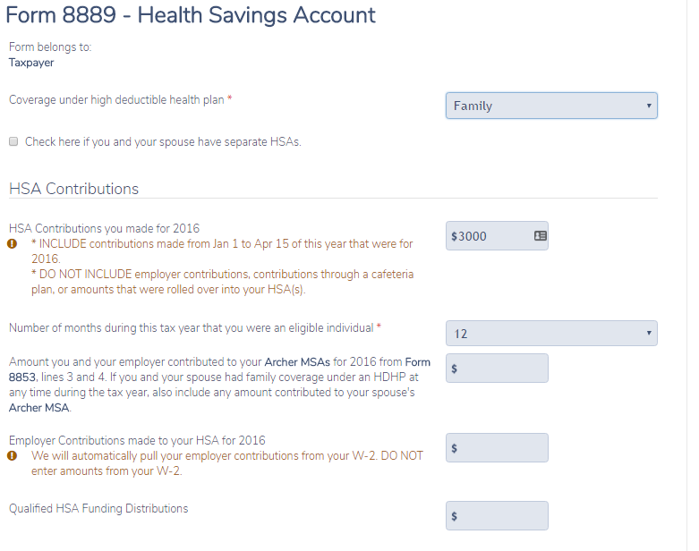
Step 7
Step 6
Step 5
Step 4
Step 3
Step 2
Step 1
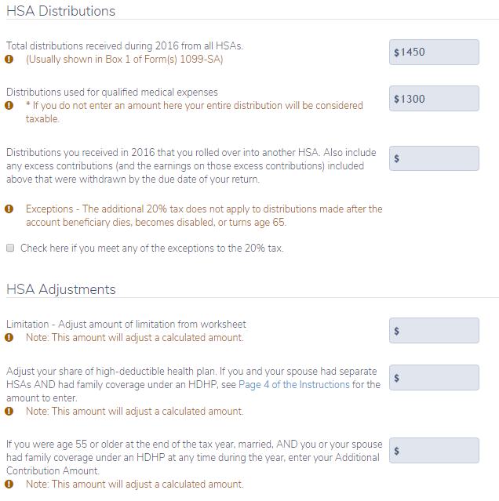
Step 12
Step 14
Step 13
Step 11
Step 10
Step 8
Step 9
HSA for New Jersey

Most of the tax benefits of an HSA do not apply to New Jersey.
Distributions for unreimbursed qualified medical expenses (the amount in line 15 of the 8889) should be added to NJ 1040 Line 30.
Contributions (Form 5498-SA)
- Contributions (Employer and Employee) are included in W-2 NJ box 16 and are taxed accordingly.
Distributions (Form 1099-SA)
- Because HSA distributions used for medical expenses are not reported on federal Sch A, they must be manually accounted for on NJ-1040 line 30. (Enter in NJ Return – Subtractions from income – Medical insurance premiums that you did not include on your federal return because they were deducted on a pre-tax basis.)
- Distributions from an HSA account that are not qualified distributions are entered as income on 1040 line 21. The amount will be passed to NJ Other Income line 25. Remove this income from the NJ return (NJ Return – Income subject to tax – Taxable Amount of Scholarships included on Federal Return – enter as a negative number)

